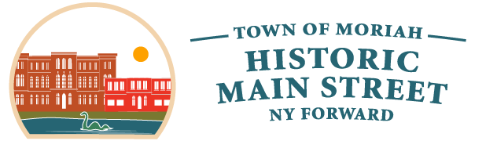
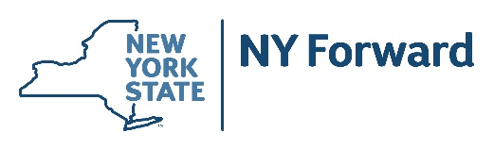

Town of Moriah

Town of Moriah

38 Park Pl STE 1

Port Henry, NY 12974

PRESS RELEASE

FOR IMMEDIATE RELEASE Contact: Matthew Brassard
July 14, 2026 Phone: 518-546-8631

Town of Moriah to Host First Local Planning Committee Meeting and Public Engagement Events for NY Forward

Port Henry, N.Y. – The Town of Moriah is pleased to announce the kick-off of the NY Forward planning process. The first Local Planning Committee (LPC) meeting is scheduled for Wednesday, August 5, 2026, at 12:00 PM at the Town Court, 42 Park Place, Port Henry, NY 12974. The meeting is open to the public and will include an opportunity for public comment at the conclusion of the meeting.

The Town of Moriah and its Local Planning Committee invite residents, business owners, property owners, and other stakeholders to participate in two upcoming public engagement events. Public participation is a vital part of the NY Forward planning process and will help shape the vision and priorities for the future of downtown Moriah.

A Public Open House will be held on Wednesday, August 5, 2026, from 5:00 to 7:00 p.m. at the Knights of Columbus, 4253 South Main Street, Port Henry, NY 12974. The interactive Open House will provide opportunities for community members and visitors to share ideas, identify opportunities, and help the LPC develop a vision statement and goals for the NY Forward Strategic Investment Plan. A brief presentation introducing the NY Forward Program and planning process will begin at 5:15 p.m. Community members of all ages are encouraged to attend and participate.

The following morning, Thursday, August 6, from 8:00 to 10:00 a.m., the consultant team will host Lakeside Coffee with Consultants at the Port Henry Beach Pavilion on Beach Road. Residents, business owners, and prospective project sponsors are invited to stop by for coffee, ask questions about the NY Forward Program, discuss project ideas, and meet one-on-one with members of the planning team in an informal setting. Coffee and light refreshments will be provided.

In addition, project applications will be accepted starting August 5, 2026, through September 9, 2026 through the NY Forward Call for Projects. During the Open Call for Projects, property owners, businesses, local government and non-profit sponsors are invited to submit project proposals that could help revitalize downtown Moriah and advance the community’s vision. To be considered for the NY Forward program, all potential projects must be submitted by 4:00 PM on September 9, 2026. NY Forward Program requirements and project application materials can be found on the project website.

To support this process, the consultant team will host a virtual introduction and overview of the Call for Projects on Thursday, August 13 from 12:00 – 1:00 PM. Following the presentation, residents and potential project sponsors will have an opportunity to ask questions, discuss project ideas, and learn more about the submission process.

For more information and to follow along with the NY Forward process, please visit the Moriah NY Forward website at www.MoriahNYForward.com

NY Forward is a central component of the State's economic development efforts, working together with the Downtown Revitalization Initiative (DRI), to accelerate and expand the revitalization of New York's downtowns. NY Forward serves smaller communities with historic character that distinguishes them from the larger, more urban central business districts typically funded through DRI. NY Forward communities are walkable, less dense areas that serve the immediate local community, and are more local in nature - focusing on the immediately surrounding residential or rural agricultural centric development. Governor Kathy Hochul has committed $100 million for the fourth round of the NY Forward program. Each of the State’s ten Regional Economic Development Councils (REDCs) recommended two communities for NY Forward awards. In the North Country Region, Heuvelton and Moriah were each the recipients of $4.5 million.

NY Forward is led by the Department of State, in close partnership with Empire State Development, NYS Homes and Community Renewal and New York State Energy Research and Development Authority.

The Local Planning Committee (LPC) includes local and regional leaders, stakeholders, and community representatives. LPC members will attend a variety of meetings at which they will be asked to brainstorm ideas, provide direction to consultants, review planning products, prioritize actions and evaluate potential projects. The Town of Moriah Supervisor Matthew Brassard and James McKenna, North Country Regional Economic Development Council co-chair, are the Moriah LPC Co-Chairs.

Supervisor Matthew Brassard, LPC Co-Chair said, "NY Forward is an exciting opportunity for our Town. Being recognized for this round of the State’s NY Forward program is electrifying and we look forward to working in partnership with the Local Planning Committee and community to identify transformational projects that will revitalize our downtown.”

James McKenna, North Country Regional Economic Development Council co-chair and LPC Co-Chair, said, "The Town of Moriah is rich in history, natural beauty, and community pride. Through the NY Forward program, we have an exciting opportunity to build on those strengths by investing in projects that enhance downtown, support local businesses, attract visitors, and create lasting benefits for residents. I look forward to working with the community to develop a shared vision for the future."

Public engagement is a key component of the NY Forward planning process and fundamental to the success of NY Forward. The objective of public engagement is to ensure that all stakeholders have ample opportunity to be informed about the NY Forward process and its intended outcomes; to comment on the process as it progresses; to express their concerns and contribute ideas; and to participate in building a consensus about the vision for the downtown and other outcomes, culminating in a locally supported NY Forward Strategic Investment Plan. Public workshops and engagement activities will be scheduled throughout the effort to allow opportunity for public input. More information about NY Forward can be found at https://www.ny.gov/programs/ny-forward.

The NY Forward process is being facilitated by a consultant team led by M.J. Engineering, Architecture, Landscape Architecture and Land Surveying, P.C. and supported by Andropogon, E.M. Pemrick & Company, and Captain Consulting.

###

